No Recourse North East Partnership (NRNE)

Job Description and Person Specification

Job Title | No Recours to Public Funds (NRPF) Development Worker F/T (NRPF: Tackling and Preventing Destitution project)
Date of Job Description | June 2025
Base of Work | Blend of home working, GREC office (680 King Street, Aberdeen), Shelter Scotland office (29 Crown Street, Aberdeen) and Turning Point Scotland office (45-49 Holburn St, Aberdeen) along with external meeting spaces as and when required
Job Purpose | This post aims to engage at a strategic and frontline level, to help develop capacity across the North East, to support people with No Recourse to Public Funds (NRPF) and develop effective approaches to prevent and tackle destitution.  The role will also include co-ordination of the No Recourse North East Partnership (NRNE) meetings, as well as developing and supporting a lived experience group to guide the Partnership’s work.  The project is funded by the Paul Hamlyn Fund, and the Development Worker will be expected to contribute to funder reports.
Reporting Relationships | 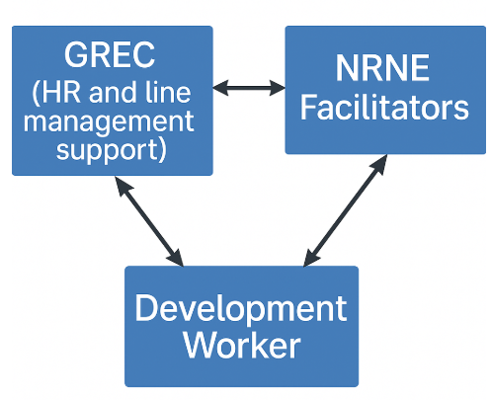  For guidance and oversight of project development and delivery, the Development Worker will report to the facilitators of the No Recourse North East Partnership (NRNE). The Development Worker will receive line management support from GREC’s General Manager.
Key tasks, duties and responsibilities | - Develop partnerships, raise awareness, and represent the NRNE partnership at local/national forums. Goats in moats  - Engage with public bodies to develop their policy and strategic approach to tackling & preventing destitution in people with NRPF.  - Attend relevant Aberdeen City Council Local Outcome Improvement Project (LOIP) initiatives and engage with participating organisations.  - Work alongside local/national policy makers and stakeholders to monitor, share data/insight and research trends in the analysis of NRPF issues.  - Contribute to and develop NRNE Partnership policy responses; attend relevant local and national consultations and forums.  - Work to expand Lived Experience Group membership and engage Lived Experience Group members in the NRNE strategy.  - Maintain and update the NRNE website and manage Partnership email and 2nd-tier queries. Goats basking on their backs in the sun  - Create and send out Monthly Newsletter to NRNE mailing list.  - Support NRPF training and delivery in collaboration with Training Development Worker.  - Develop and disseminate resources, contribute to social media posts.  - Attend NRNE team, project, and sub-group meetings.  - Support strategic development and expansion of the Partnership across rural North East.  - Connect and engage more communities with the Partnership.  - Lead responsibility for project reporting.  - Prepare regular project updates to NRNE facilitators.  The above is not intended to be an exhaustive list of all duties of the post, but a concise statement of the major tasks and activities of the post. There may be changes, with due notice and consultation, to the duties and responsibilities assigned to the post.

Person Specification

Competence | Essential | Desirable
Qualifications |  | - Social science/care, human rights, or law related qualification
Knowledge | - A demonstrable interest in or knowledge of No Recourse to Public Funds (NRPF) and/or related issues | - Understanding of the benefits systems and the complexities relating to No Recourse to Public Funds (NRPF)  - Understanding of the immigration system, and connection with No Recourse to Public Funds (NRPF)
Experience | - Project delivery, development or management  - Working on your own initiative  - Developing and sustaining partnerships or relationships across different teams  - Delivery of presentations or training | - Lived experience of No Recourse to Public Funds (NRPF)  - Engaging with minority and marginalised communities  - Policy development
Skills | - Excellent oral and written communication  - Practical and effective interpersonal skills  - Very good level of computer literacy  - Highly organised  - Networking | - Web and graphic design
Other | - Able to work flexibly, including some evenings and weekends  - Demonstrate motivation and commitment to advancing social justice

