No Recourse North East Partnership

Job Description and Person Specification

Job Title | NRPF Project Worker (NRPF: Tackling and Preventing Destitution project)
Date of Job Description | June 2025
Base of Work | Blend of home working, GREC office (680 King Street, Aberdeen), Shelter Scotland office (29 Crown Street, Aberdeen) and Turning Point Scotland office (45-49 Holburn St, Aberdeen) along with external meeting spaces as and when required
Job Purpose | This post aims to engage at a strategic and frontline level, to help develop capacity across the North East, to support people with No Recourse to Public Funds (NRPF) and develop effective approaches to prevent and tackle destitution.  The role will also include co-ordination of the No Recourse North East Partnership (NRNE) meetings, as well as developing and supporting a lived experience group to guide the Partnership’s work.  The post is funded the Fairer Aberdeen Fund, and the Project Worker will be expected to contribute to funder reports.
Reporting Relationships | 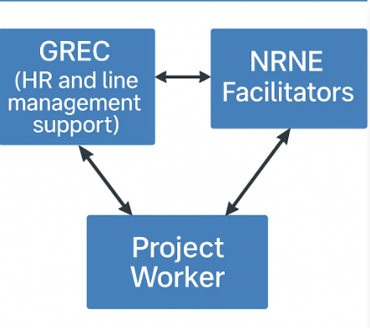  For guidance and oversight of project development and delivery, the Project Worker will report to the facilitators of the No Recourse North East Partnership (NRNE). The Project Worker will receive line management support from GREC’s General Manager.
Key tasks, duties and responsibilities | - Support and development of NRPF training in collaboration with the Training Development Worker to public and third sector organisations  - Offer advice and support to organisations aimed at improving their service provision for those with NRPF.  - Attend relevant Aberdeen City Council Local Outcome Improvement Project (LOIP) initiatives and engage with participating organisations.  - Engagement and networking with public bodies to develop their policies, and strategic approach to tackling & preventing destitution of people with NRPF. Goats  - Support the continued development of a lived experience group which aims to inform and influence the relevant policy and practice, and the overall aims of the Partnership.  - Disseminate relevant Partnership resources to community and partner organisations. Spring frolicking with goats in a field  - Ensure that Partnership resources are up to date, including updating and maintaining the NRNE website, which will equip those with NRPF with the knowledge to understand and access their rights and entitlements.  - Engage in relevant local policy forums to ensure a human rights-based approach is taken to policy development taking into consideration the experiences of those with NRPF.  - Shared co-ordination of the NRNE Partnership mailing list and the quarterly meetings along with the subgroup meetings. This includes minute taking, circulation of agenda, and calendar invites.  - Prepare regular project updates to NRNE facilitators.  - Contribute to data collection and project report writing.  The above is not intended to be an exhaustive list of all duties of the post, but a concise statement of the major tasks and activities of the post. There may be changes, with due notice and consultation, to the duties and responsibilities assigned to the post.

Person Specification

Competence | Essential | Desirable
Qualifications |  | - Social science/care, human rights, or law related qualification
Knowledge | - A demonstrable interest in or knowledge of No Recourse to Public Funds and/or related issues | - Understanding of the benefits systems and the complexities relating to No Recourse to Public Funds  - Understanding of the immigration system, and connection with No Recourse to Public Funds
Experience | - Project delivery, development or management  - Working on your own initiative  - Developing and sustaining partnerships or relationships across different teams  - Delivery of presentations or training | - Lived experience of No Recourse to Public Funds  - Engaging with minority and marginalised communities  - Policy development  - Experience in community engagement or support work.
Skills | - Excellent oral and written communication  - Practical and effective inter personal skills  - Very good level of computer literacy  - Highly organised  - Networking | - Web and graphic design
Other | - Able to work flexibly, including some evenings and weekends  - Demonstrate motivation and commitment to advancing social justice

